**Office 365 from Home**

**Quick Start Guide**

From the School District web page click on the **Utility Links** drop down menu and then the **Office 365** link.

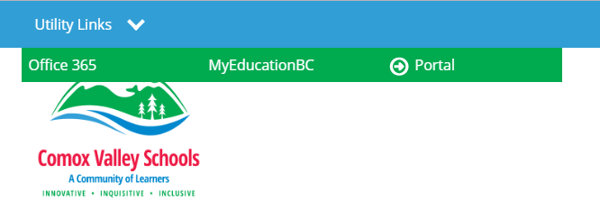

At school this will automatically log students into their account.

From home you will get a screen asking them to sign-in to their account.

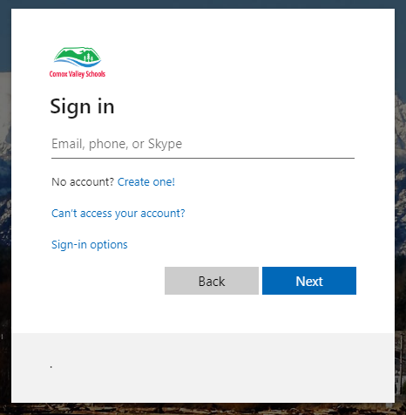

Make sure they are signing in using their **school email**.

School email is formatted: [student#@lean71.ca](mailto:student#@lean71.ca) eg. [1234567@learn71.ca](mailto:1234567@learn71.ca)

The password will be the same one used to sign into the school computers.

First initial + last initial + last four digits of their student # eg. ab4567

After this, when they need to sign in from that machine it should give them the option to click on their account to sign in.

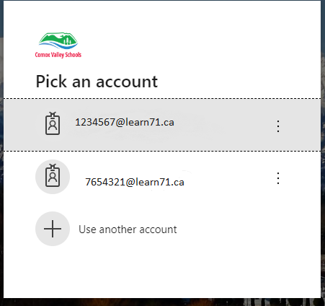

Note that you can have multiple accounts attached to the same machine - see below!

If a student needs to use a different machine, they will have to do the initial sign-in procedure.

**Office 365 homepage**

Below is a screenshot of some the apps available to students from the Office 365 homepage

**Outlook** is their school email.

**OneDrive** is where all their documents are automatically saved if they are working online or have

AutoSave turned on.

**Word, Excel** and **PowerPoint** are the apps students tend to use the most.

Some teachers may have set up **Class Notebook** for students as well.

When signed in, you have the option of downloading a **FREE and up to date** copy of the Office Suite of tools for your home computer.

Do this by clicking on the Install Office button near the top of this page.

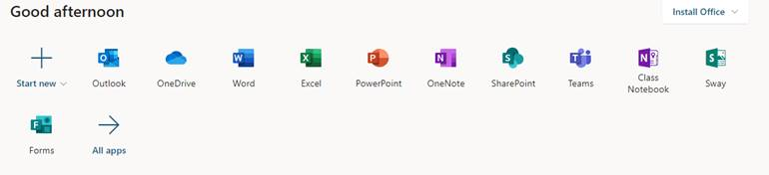

**Turn on AutoSave**

If you are working on a document within the desktop application and not in the cloud-based app, be sure to turn on the AutoSave function so your document is automatically saved to your OneDrive folder.

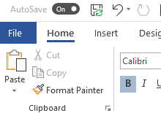

When you are linked to the cloud the little green circle will appear on the save icon

**Sign into the correct account**

If you have multiple users at home using the same device, make sure they are signed into their own account and not one of the others or they will not be able to find; work on or save their own work.

This means the previous user needs to sign out.

Do this by clicking on the little circle icon in the upper right-hand corner of any Office 365 App.

It will probably just be their initials as opposed to a picture as in this screenshot.

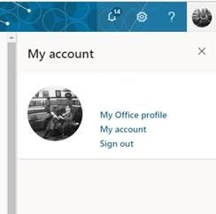

Please be aware that if a user does not log out of their account, it is possible for others to have access to their documents, email etc.